EXPERIMENT NO. 5
Implement Classes, Objects and Member Methods

PART B – TO BE COMPLETED BY STUDENTS
Roll No. C-60
Name Avdhut Parish Madhavi
Class / Division SE-C
Batch C2
Date of Experiment ________________________________________________
Date of Submission ________________________________________________
Grade ________________________________________________

B.1 Document Created by the Student
Create a class for another healthcare entity and instantiate at least two objects.
Healthcare entity selected: Doctor
The Doctor class contains the doctor ID, name, and specialization. Two objects are created with different values, and their details are displayed using a member method.

B.2 Student Program / Output
Paste/write the final program and attach or reproduce the observed output below.
class Doctor {
int id;
String name;
String specialization;

void display() {
System.out.println("Doctor ID : " + id);
System.out.println("Name : " + name);
System.out.println("Specialization : " + specialization);
System.out.println();
}
}

public class DoctorObjectDemo {
public static void main(String[] args) {
Doctor d1 = new Doctor();
d1.id = 201;
d1.name = "Rahul";
d1.specialization = "Cardiology";

Doctor d2 = new Doctor();
d2.id = 202;
d2.name = "Priya";
d2.specialization = "Neurology";

d1.display();
d2.display();
}
}
Output:
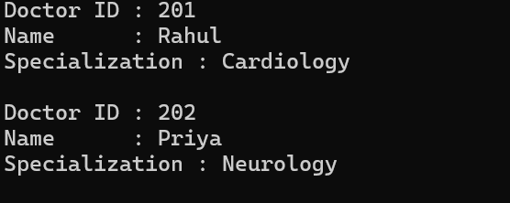

B.3 Observations and Learning
- What is the difference between a class and an object?
A class is a blueprint that defines data members and methods. An object is an instance of a class that contains its own data.

- Why can two objects of the same class contain different values?
Each object has its own instance variables. Therefore, objects of the same class can store different values for their data members.

- What is the role of the new keyword?
The new keyword creates an object of a class and allocates memory for it.

Student observation / learning:
The experiment demonstrated how to define a class, declare instance variables, create objects using the new keyword, and invoke member methods. The two Doctor objects stored different information and displayed their details independently.

B.4 Conclusion
Object modeling of healthcare systems is explicitly included as a syllabus self-learning context.
Student conclusion:
The experiment successfully demonstrated the concepts of classes, objects, instance variables, and member methods in Java. Two objects of the Doctor class were created and used to display different doctor details.

B.5 Questions of Curiosity
- What is the difference between a class and an object?
A class is a blueprint that defines the properties and behavior of objects. An object is an instance of that class.

- How does object creation take place in Java?
Object creation takes place using the new keyword, followed by the class constructor.
Example:
Doctor d1 = new Doctor();
Here, Doctor is the class, d1 is the reference variable, and new Doctor() creates the object.

- Why can objects of the same class contain different values?
Objects of the same class have separate copies of instance variables. Each object can store different values depending on the data assigned to it.

